大作业：json模块提取
本题针对json文件进行处理。你可以查询互联网（如https://www.runoob.com/json/json-syntax.html）或者咨询大语言模型，以了解json语法。

例如，下面是一种特定的json文件和它的图形化表示。文件包含9个结点的数组（以id作为标识，部分类型结点并未显示）。
[  {  "id": "135c4e7649611314",  "type": "tab",  "label": "PowerSaver",  "disabled": false,  "info": "",  "env": []  },  {  "id": "cf5908a52e0aee5e",  "type": "ps-receive-price",  "z": "135c4e7649611314",  "name": "Price Receiver",  "x": 400,  "y": 320,  "wires": [  [  "b7b85590b7d28ba6"  ]  ]  },  {  "id": "b08bc12bf8734c5a",  "type": "tibber-query",  "z": "135c4e7649611314",  "name": "",  "active": true,  "apiEndpointRef": "9ea07b03b88cb526",  "x": 230,  "y": 320,  "wires": [  [  "cf5908a52e0aee5e"  ]  ]  },  {  "id": "d0d4dd31efe67e85",  "type": "inject",  "z": "135c4e7649611314",  "name": "",  "props": [  {  "p": "payload"  },  {  "p": "topic",  "vt": "str"  }  ],  "repeat": "60",  "crontab": "",  "once": true,  "onceDelay": "1",  "topic": "",  "payload": "{ viewer { homes { currentSubscription { priceInfo { today { total startsAt } tomorrow { total startsAt } } } } } }",  "payloadType": "str",  "x": 90,  "y": 320,  "wires": [  [  "b08bc12bf8734c5a"  ]  ]  },  {  "id": "4831f393a0066565",  "type": "api-call-service",  "z": "135c4e7649611314",  "name": "Set temperature",  "server": "e2dd69fb.8f70a8",  "version": 3,  "debugenabled": false,  "service_domain": "climate",  "service": "set_temperature",  "entityId": "climate.my_climate",  "data": "{\"entity_id\":\"climate.my_climate\",\"temperature\":\"{{adj_setpoint}}\"}",  "dataType": "json",  "mergecontext": "",  "mustacheAltTags": false,  "outputProperties": [],  "queue": "none",  "x": 980,  "y": 320,  "wires": [  []  ]  },  {  "id": "9ea07b03b88cb526",  "type": "tibber-api-endpoint",  "feedUrl": "wss://api.tibber.com/v1-beta/gql/subscriptions",  "queryUrl": "https://api.tibber.com/v1-beta/gql",  "name": "Tibber"  }, | （此段代码接左边）  {  "id": "027f4267d969e1b8",  "type": "server-state-changed",  "z": "135c4e7649611314",  "name": "Setpoint",  "server": "e2dd69fb.8f70a8",  "version": 3,  "exposeToHomeAssistant": false,  "haConfig": [  {  "property": "name",  "value": ""  },  {  "property": "icon",  "value": ""  }  ],  "entityidfilter": "input_number.setpoint",  "entityidfiltertype": "exact",  "outputinitially": true,  "state_type": "num",  "haltifstate": "",  "halt_if_type": "str",  "halt_if_compare": "is",  "outputs": 1,  "output_only_on_state_change": false,  "for": 0,  "forType": "num",  "forUnits": "minutes",  "ignorePrevStateNull": false,  "ignorePrevStateUnknown": false,  "ignorePrevStateUnavailable": false,  "ignoreCurrentStateUnknown": true,  "ignoreCurrentStateUnavailable": true,  "outputProperties": [  {  "property": "payload.config.setpoint",  "propertyType": "msg",  "value": "",  "valueType": "entityState"  },  {  "property": "data",  "propertyType": "msg",  "value": "",  "valueType": "eventData"  },  {  "property": "topic",  "propertyType": "msg",  "value": "",  "valueType": "triggerId"  }  ],  "x": 420,  "y": 360,  "wires": [  [  "b7b85590b7d28ba6"  ]  ]  },  {  "id": "b7b85590b7d28ba6",  "type": "ps-strategy-heat-capacitor",  "z": "135c4e7649611314",  "name": "Heat capacitor",  "timeHeat1C": "70",  "timeCool1C": 50,  "maxTempAdjustment": "1",  "boostTempHeat": "2",  "boostTempCool": "2",  "minSavings": 0.08,  "setpoint": 23,  "x": 600,  "y": 320,  "wires": [  [  "2b7cbdef3203a482"  ],  [],  []  ]  },  {  "id": "2b7cbdef3203a482",  "type": "function",  "z": "135c4e7649611314",  "name": "Adjust setpoint",  "func": "//In case the climate entity can only handle integers\n//Calculate rounded setpoint for the climate entity and return the msg\nmsg.adj_setpoint=Math.round(msg.payload);\nreturn msg\n",  "outputs": 1,  "noerr": 0,  "initialize": "",  "finalize": "",  "libs": [],  "x": 800,  "y": 320,  "wires": [  [  "4831f393a0066565"  ]  ]  }  ]
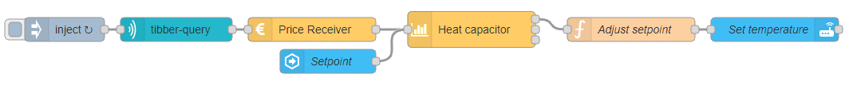

我们可以重构结点之间的单向关系，包括：
- wires中的结点连接关系，代表当前结点和另外一组结点的连接关系，wires表明单向连接关系，后面跟随一个数组，本例子中，我们以wires[0]来构建连接关系。
- 属性关系，如某结点的属性"z": "135c4e7649611314" 表明该结点和135c4e7649611314结点存在z关联。

- 注意1：所有结点均通过id进行连接；我们忽略未在当前文件中定义的结点。
- 注意2：图中可能存在环。

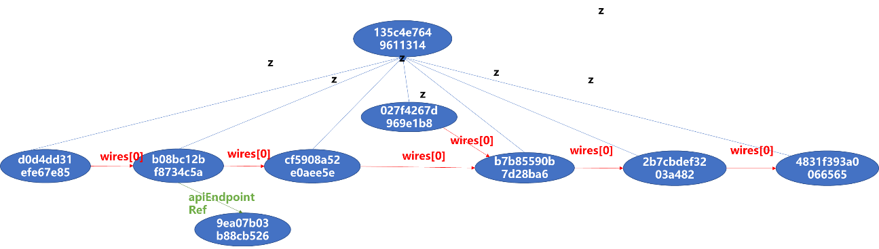

我们希望从这个图中提取一部分子图，并以原形式予以保存。提取功能如下：
- 输入文件（或者目录），输入子图结点数量上界m1和下界m2，则提取出所有满足结点数量要求的子图（结点数组）。例如，用户输入5 6，则生成5个结点或者6个结点的模块文件，每个模块中结点均在当前模块中可达，示例结果如下表（部分结点文字内容省略）。
- 输出文件要求：所生成的模块文件还是json数组形式。文件命名规则如下：如果输入文件为abc.json，则输出文件为同一目录下的一组文件：module_abc_5_2.json，代表结点数量为5，第2个满足上述需求的模块文件。

module_abc_5_1.json  [  {  "id": "135c4e7649611314", …  },  {  "id": "4831f393a0066565",  "type": "api-call-service",  "z": "135c4e7649611314",  "name": "Set temperature",  "server": "e2dd69fb.8f70a8",…  "wires": [  []  ]  },  {  "id": "027f4267d969e1b8",  "type": "server-state-changed",  "z": "135c4e7649611314",…  "wires": [  [  "b7b85590b7d28ba6"  ]  ]  },  {  "id": "b7b85590b7d28ba6",  "type": "ps-strategy-heat-capacitor",  "z": "135c4e7649611314",…  "wires": [  [  "2b7cbdef3203a482"  ],  [],  []  ]  },  {  "id": "2b7cbdef3203a482",  "type": "function",  "z": "135c4e7649611314",  …  "wires": [  [  "4831f393a0066565"  ]  ]  },  ] | module_abc_5_2.json  [  {  "id": "135c4e7649611314", …  },  {  "id": "cf5908a52e0aee5e",  "type": "ps-receive-price",  "z": "135c4e7649611314", …  "wires": [  [  "b7b85590b7d28ba6"  ]  ]  },  {  "id": "4831f393a0066565",  "type": "api-call-service",  "z": "135c4e7649611314",  "name": "Set temperature",  "server": "e2dd69fb.8f70a8",…  "wires": [  []  ]  },  {  "id": "b7b85590b7d28ba6",  "type": "ps-strategy-heat-capacitor",  "z": "135c4e7649611314",…  "wires": [  [  "2b7cbdef3203a482"  ],  [],  []  ]  },  {  "id": "2b7cbdef3203a482",  "type": "function",  "z": "135c4e7649611314",  …  "wires": [  [  "4831f393a0066565"  ]  ]  },  ] | module_abc_6_1.json  [  {  "id": "135c4e7649611314", …  },  {  "id": "cf5908a52e0aee5e",  "type": "ps-receive-price",  "z": "135c4e7649611314", …  "wires": [  [  "b7b85590b7d28ba6"  ]  ]  },  {  "id": "4831f393a0066565",  "type": "api-call-service",  "z": "135c4e7649611314",  "name": "Set temperature",  "server": "e2dd69fb.8f70a8",…  "wires": [  []  ]  },  {  "id": "027f4267d969e1b8",  "type": "server-state-changed",  "z": "135c4e7649611314",…  "wires": [  [  "b7b85590b7d28ba6"  ]  ]  },  {  "id": "b7b85590b7d28ba6",  "type": "ps-strategy-heat-capacitor",  "z": "135c4e7649611314",…  "wires": [  [  "2b7cbdef3203a482"  ],  [],  []  ]  },  {  "id": "2b7cbdef3203a482",  "type": "function",  "z": "135c4e7649611314",  …  "wires": [  [  "4831f393a0066565"  ]  ]  },  ]

扩展功能：用户可以指定1个或者多个属性名，则在计算过程中，不构建该属性相关的连接，例如，用户指定z，则提取子图过程中，不考虑z属性产生的连接关系。输出文件要求：如果输入文件为abc.json，则输出文件为同一目录下的一组文件：module_abc_z_5_2.json，代表abc.json文件中，不考虑z属性，结点数量为5，第2个满足上述需求的模块文件。

你的工具至少支持如下执行命令：
- mytool 目标目录地址 [下界, 上界] [指定0个或者多个标签]
- mytool 目标文件地址 [下界, 上界] [指定0个或者多个标签]

测试中，我们提供一组文件夹，请遍历访问该目录中所有json文件（这些文件不以module开头），生成相关的module文件（仍然放置在原目录中）。我们将根据生成结果情形，检查功能的完整性和正确性。

提示：你可以采用任意工具解析json文件格式，课程组将不做限定。请包含库文件，并在readme中明确标注执行方式。为了便于调试，你可以修改测试数据以进行实验。如果测试数据存在问题，可以自动补全括号，或者直接报错。

